28.20: On the top wire: 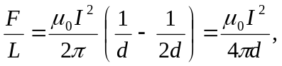 upward.
On the middle wire, the magnetic fields cancel so the force is zero.
On the bottom wire: 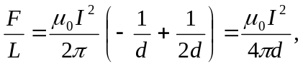 downward.

